Note: Include this page only when adding / amending / deleting a document. If using this document as a record, this Revision History page can be omitted.

REVISION HISTORY

Revision no | Date | Description of Changes | Reason for Revision | Revised by | Approved by
2 | 01 Jun 13 | Add revision history page | - Recommendation from Stage 2 audit | RDPlacido
3 | 01 May 14 | Deleted Quarterly Performance Report | - Delete unnecessary report | LDLacuna
4 | 8 Apr 16 | Added disclaimer when printing the document | For document control | RCGanal | MVBergantin
5 | 8 Feb 17 | Changed Quarterly to Semestral evaluation | Changed frequency of evaluation | MVBergantin
6 | 16 Nov 17 | Removed Semestral Points and CQP in definition of terms | -Revised Performance Management Policy | JGAdra
7 | 8 Jan 18 | Added details of Note 5 | -Observation during IQA | JGAdra
TM-BR-MG- 11 Rev02, 10302015

I. Objective
To evaluate the job performance and attitude of the employee towards work based on the company standards on a semester basis and manage the performance of the employee through executing appropriate measures in order to achieve quality and desirable output.
II. Scope
This procedure defines the action and responsibilities of the HR Head and Immediate Unit Heads in the performance management. This covers activities from the dissemination of the performance evaluation forms to the recording of the results.
III. Definition of Terms
Performance Evaluation History Card | Is a history card enclosed in the 201 file folder of the employee. It shows the summary of records of the performance ratings that the employee received.

IV. Procedure Details
Responsible | Activity | Interface
HR Head | 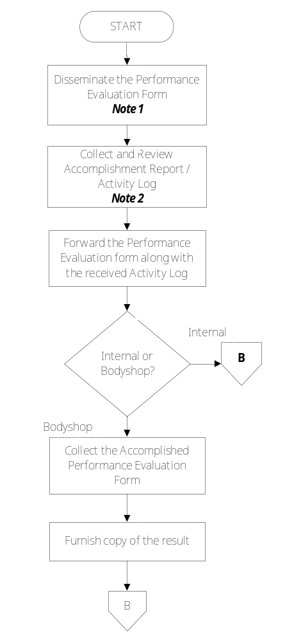 | Guidelines for Forms Dissemination, Collection, Analysis and Review Performance Evaluation Form Performance Evaluation Tracker  Performance Evaluation Forms  Employees  Clients  Unit Heads / Clients Accomplished Performance Evaluation Forms  Unit Head / Account Manager Employee
Responsible | Activity | Interface
HR Head Unit Heads / Account Managers  HR Head | 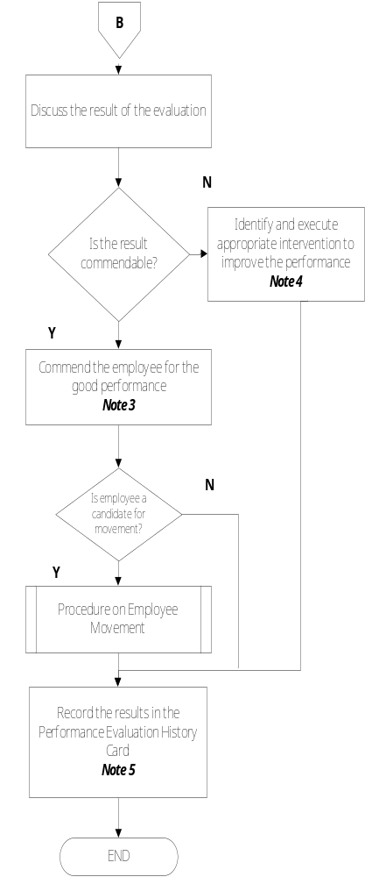 | Employee  Procedure on Employee Movement  Performance Evaluation History Card ManCom
Notes:
- The dissemination of the performance evaluation form is scheduled depending on the following:
Regular and contractual employees – every 6 months
The Performance Evaluation Form will be disseminated personally or sent via electronic mail, whichever is more practical.
- Accomplishment Report / Activity Log is just the summary of their major accomplishment / activities performed and completed for a certain period of time. The file may be sent separately or it could also be written in the space provided in the Performance Evaluation Form.
- The employee may be commended by his Unit Head / HR Head / Account Manager by any means which will boost the morale of the employee.
- Non-commendable performance evaluation is if it is below average or poor. The corrective and preventive measures will be performed by the Unit Head / Account Manager and will be assisted by the HR Head. Corrective and preventive action could be re-training, coaching, counseling or whatever appropriate. See Guidelines.
- Performance evaluation results should be recorded in the performance evaluation history card and form must be updated and information must be completely filled in.

V. References
- Performance Evaluation Form (GENIISYS)
- Performance Evaluation Form (Bodyshop – Development)
- Performance Evaluation Form (Admin and Non-Development)
- Performance Evaluation Form (System Analysis)
- Contractor’s Scorecard
- Performance Evaluation History Card
- Guidelines for PE Forms Dissemination, Collection, Communication and Review
- Guidelines for Employee Termination
- Procedure on Employee Movement

- Quality Records
- Accomplished Performance Evaluation Form (GENIISYS)
- Performance Evaluation Form (Bodyshop – Development)
- Accomplished Performance Evaluation Form (Admin and Non-Development)
- Accomplished Performance Evaluation Form (System Analyst)
- Accomplished Contractor’s Scorecard
- Updated Performance Evaluation History Card
- Performance Evaluation Tracker
- Incident Report
- Memorandum

